**C**

*Certificate of Currency, Cattle Herd Health Status Declaration, GST status & current*

*Evidence of ‘PESTI VIRUS’ results must be available upon request.*

*Certificate of Currency, Cattle Herd Health Status Declaration, GST status & current*

*Evidence of ‘PESTI VIRUS’ results must be available upon request.*

**CASINO SHOW SOCIETY INC.**

**131st Anniversary Show**

# 10th & 11th October 2025

# CERTIFICATE OF ENTRY

This Certificate together with the entry fee must reach the **Secretary, Casino Show Society Inc., P.O. Box 192 Casino 2470**, **Electronic Transfers BSB 032536**

**Acc 208631** on or before the closing date as per the Schedule. Exhibitors are requested to answer all questions in this Certificate. The details supplied will be catalogued and the Society will not be responsible for any omissions.

|  |  |  |  |  |  |  |  |  |
| --- | --- | --- | --- | --- | --- | --- | --- | --- |
| **Office use Only** | **Class No.** | **Name of Exhibit** | **Herd Book** | **Tattoo**  **/Fire** | **Date of Birth** | **Name of Sire** | **Name of Dam** | **Entry Fee**  (incl. GST) |
|  |  |  |  |  |  |  |  |  |
|  |  |  |  |  |  |  |  |  |
|  |  |  |  |  |  |  |  |  |
|  |  |  |  |  |  |  |  |  |
|  |  |  |  |  |  |  |  |  |
|  |  |  |  |  |  |  |  |  |
|  |  |  |  |  |  |  |  |  |
|  |  |  |  |  |  |  |  |  |
|  |  |  |  |  |  |  |  |  |
|  |  |  |  |  |  |  |  |  |

1. **I hereby apply to enter the above exhibits in terms of and upon the conditions as set out in the Society’s Regulation, which I have read and by which I agree to be bound, and I hereby certify to the correctness of the particulars as set out below.**
2. **This Certificate of Entry and the Regulations shall constitute the whole agreement upon which entries are submitted and I agree that all representations and statements not appearing therein or the regulations are hereby excluded.**
3. **I further agree to exhibit at the Casino Show at my own risk and advise that I will not make any claim against the Society or any of its committees for any injury or loss sustained or caused by my actions at the Show.**

**Breed of Cattle:** ………..…………………….…..…...…….. **No. of head:** ……….

***Current Certificate of Currency for $20 Million Public Liability to be attached,***

***Entry not valid until received with payment and all required paper work***

**Expiry Date:** …………………… **Cattle Status: __** JBAS6 **__** JBAS7**__** JBAS8

**ABN:** …………………………..….. **Registered for GST: __** Yes **__** No **__** Hobby Farmer

**Name of Exhibitor/Parent/Guardian:**

…………..……………..…..…………………………………………….

**Address**: ………………...…………………………………………..

…………………………………….…..…………….……................

**Postcode:** …….… **Phone:** ………...…..……………………..

**Signature**: …………………………..….………………............

**Email**: ………………………………………………………………….

**Payment: Membership fees:** ……………

**Entry fees: ..**..…….….

## TOTAL: ……………

It is our policy to send a receipt by return mail to acknowledge receipt of your entry. It is the exhibitors’ responsibility to check if your entry has been received and that the details are correct.

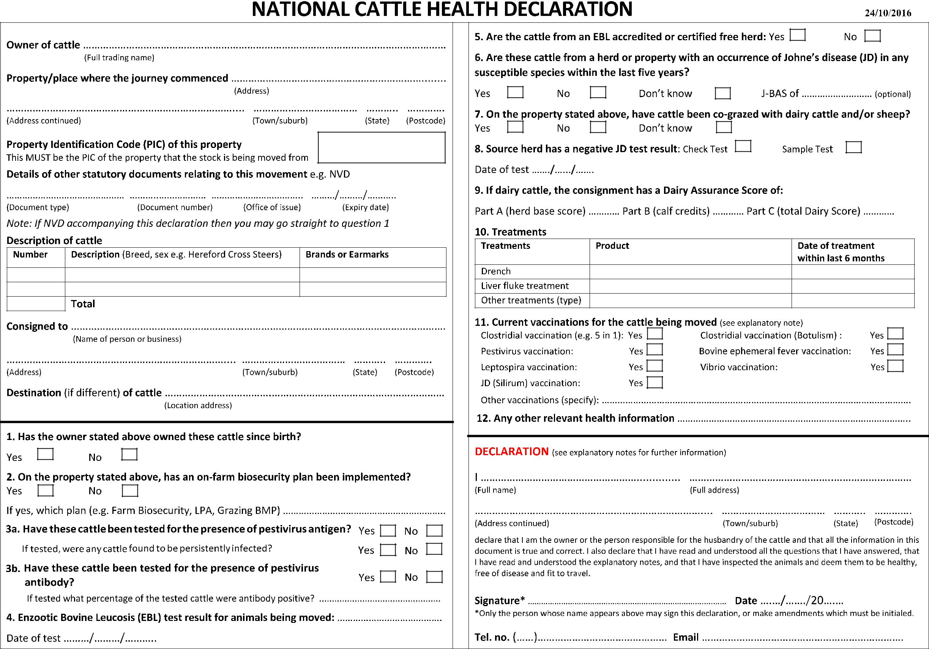

**Beef breeding date as at 1st October**

|  |  |  |  |
| --- | --- | --- | --- |
| **Exhibitors PIC #** | **Number of Head** | **Show PIC #** | **Exhibitor / Receiver PIC #** |
|  |  | **NI 122397** |  |